Complaints Procedure
The outcome of all complaints is recorded in the Summary Complaints Record file and is available for parents and OFSTED inspectors on requests.
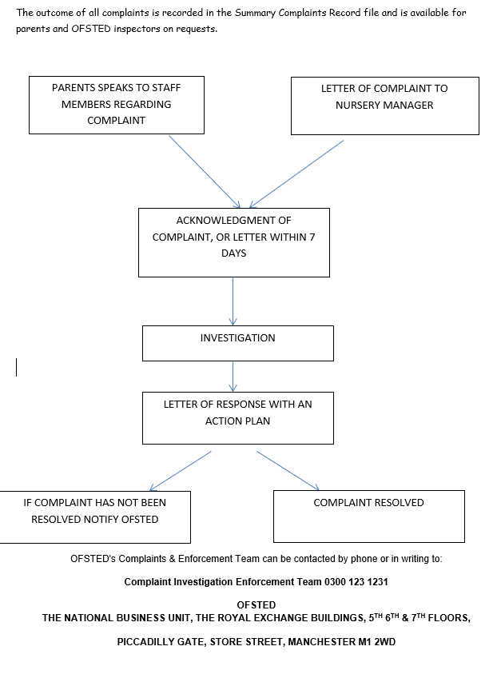
Making a complaint
Whilst aiming to achieve the highest standard of care and education for children attending Abbeymead Under 5’s and to foster a positive partnership with families, we recognise that on occasion circumstances may lead to a parent/carer wishing to make either a formal or informal complaint.
Our setting believes that children and parents are entitles to expect courtesy and prompt, careful attention to their needs and wishes. We welcome suggestions on how to improve our setting and will give prompt and serious attention to any concerns about the running of the setting. We anticipate that most concerns will be resolved quickly by an informal approach to the appropriate member of staff. If this does not achieve the desired result, we have set of procedures for dealing with concerns. We aim to bring all concerns about the running of our setting to a satisfactory conclusion for all the parties involved.
Any parent who has a concern about an aspect of the settings provision talks over first, his/her concerns with the setting leader. Hopefully, this will be resolved, if not, then please fill out a complaint form and hand in the complaint in writing to the office/management. A meeting will be arranged after the complaint has been investigated in full and will discuss the outcome. If you are still not satisfied with the outcome, then another meeting with all managers and a witness of your choice will be arranged. Written records will be taken at the meeting and all present will sign. If we can still not resolve the situation, then an external mediator will be invited (acceptable on both sides). Throughout this process, the discussions will be kept confidential. A final meeting will be called with the mediator to reach a decision on the action to be taken to deal with the complaint. Written records will be taken, and all present will sign. receives a copy. At any stage of this process, parents are within their rights to approach Ofsted directly. Ofsted’s complaints & Enforcement Team can be contacted by phone or in writing at the address above.
The outcome of all complaints is recorded in the summary Complaints record file and is available for parents and OFSTED inspectors on requests.
In the event of a parent/carer wanting to complain about a member of staff or an incident at Abbeymead Under 5’s, we would follow the following guidelines.
- Speak to a member of staff or directly to management giving as much information as possible.
- If it is discussed with a member of staff, then they will report the complaint to the manager/owner and complete a complaint form immediately.
- The manager/owner will confirm receipt of this within 24 hours
- The complaint will then be investigated, and an action plan will be drawn up to address the issue.
- Once made aware of the complaint, the manager must record the complaint and file away.
Should parents feel they cannot speak to a member of staff; the complaint can be written and sent to the manager/committee

DUTIES AS AN EMPLOYER AND EMPLOYEE
Employers have a duty of care to their employees. They should ensure they provide effective support for anyone facing an allegation and provide the employee with a named contact if they are suspended.
It is essential that any allegation of abuse made against a teacher or other member of staff or volunteer in the nursery is dealt with very quickly, in a fair and consistent way that provides effective protection for the child and at the same time supports the person who is the subject of the allegation.
PROCEDURE FOR ALLEGATION AGAINST A MEMBER OF STAFF
- Notify a member of management
- Allegation to be discussed with the LADO 01452 426994
- or discuss nature, content and context of the allegation and agree a course of action. Information such as previous history, whether the child or their family have made similar allegations and the individuals current contact with children.
- If the person is deemed to be an immediate risk to children or there is evidence of a criminal offence, the police will be involved immediately.
- The initial sharing of information may lead to a decision that no further action is to be taken in regard to the individual facing the allegation or concern; in which case this decision and a justification for it should be recorded by both the case manager and the LADO, and agreement reached on what information should be put in writing to the individual concerned and by whom. The case manager should then consider with the LADO what action should follow both in respect of the individual and those who made the initial allegation.
- The case manager should inform the accused person about the allegation as soon as possible after consulting the LADO. It is extremely important that the case manager provides them with as much information as possible at that time. However, where a strategy discussion is needed, or police or children’s social care services need to be involved, the case manager should not do that until those agencies have been consulted, and have agreed what information can be disclosed to the accused. Employers must consider carefully whether the circumstances of a case warrant a person being suspended from contact with children at the school or whether alternative arrangements can be put in place until the allegation or concern is resolved. All options to avoid suspension should be considered prior to taking that step. (Please see further information on suspension below).
- If the allegation is not demonstrably false or unfounded, and there is cause to suspect a child is suffering or is likely to suffer significant harm, a strategy discussion should be convened in accordance with working Together to Safeguard Children. If the allegation is about physical contact, the strategy discussion or initial evaluation with the police should take into account that teachers and other school and early years staff are entitled to use reasonable force to control or restrain pupils in certain circumstances.
- Where an investigation by the police or children’s social care services is unnecessary, or the strategy discussion or initial valuation decides that is the case, the LADO should discuss the next steps with the case manager. In those circumstances, the options open to the setting depend on the nature and circumstances of the allegation and the evidence and information available. This will range from taking no further action to dismissal or a decision not to use the person’s services in future. Suspension should not be the default position: an individual should be suspended only if there is no reasonable alternative.
- In some cases, further enquiries will be needed to enable a decision about how to proceed. If so, the LADO should discuss with the case manager how and by whom the investigation will be undertaken.

